Referral Agency Handbook

‘Fighting poverty at the point of need’

Thank you for deciding to be one of our referral agencies, we are extremely pleased to welcome you to the team and look forward to working together. Without the help provided by agencies like the one you represent, Ballymena foodbank would be unable to help people in need in our local community.

Provision of emergency food
- The foodbank has been established to provide short term, emergency food to individuals and families in crisis.
- Our food parcels include cereal, milk, fruit juice, soup, pasta, meat, fish, vegetables and pudding, providing balanced and nutritional meals for a minimum of three days. The quantity of food given is dependent upon the number of adults and children in the family.
- Clients are consulted on their basic dietary requirements e.g. vegetarian, gluten free, baby food etc. Outside of these requirements, our parcels are prepared according to nutritional recommendations from the Trussell Trust (in consultation with dieticians) and according to our stock levels. We are unable to offer bespoke orders to individual clients.
- Food is donated by churches, individuals, companies, community groups or charities and by the public through collection days outside the major supermarkets in our local area. This is a project that involves the whole community!
- There is no charge for the food, but it is given on the understanding that it is not resold.

Referral process
- Due to the nature of your work, we feel that you are well placed to identify people in a genuine crisis, using your professional judgement.
- As a registered referral agency, you will hold a supply of red vouchers which can be issued directly to an individual or family that you assess to be in a financial crisis leaving them with insufficient means to buy food.
- On receipt of a red voucher, the client should take it to their nearest foodbank centre - opening times and location(s) are listed at the end of this handbook.
- Volunteers at the foodbank centre will then exchange the voucher for a 3 day food parcel which the client can carry away in supermarket-branded carrier bags, giving them a degree of anonymity.
- The foodbank centre also stocks some essential non-food items which clients may benefit from such as household items, toiletries, nappies, baby food, tin openers, and pet food.
- In addition to giving food, foodbank centre volunteers also offer a free cup of tea/coffee, a friendly chat and ‘help in finding help’ by directing clients toward further support services such as debt counsellors, advocacy etc.
- In providing this ‘signposting’, we are happy to feedback any assistance or advice we have provided within the bounds of client confidentiality. Please note that each member of the foodbank centre team has signed the foodbank’s Confidentiality Agreement.
- For anyone unable to access our foodbank centre(s), we also have pre-packed emergency food boxes which can be delivered to clients if it is unreasonable for them to collect the food themselves – e.g. clients who cannot get to the foodbank due to remoteness or incapacity, or when food is required urgently outside of our normal opening hours.
- Emergency food boxes have their own voucher attached to them (yellow voucher on single boxes, green voucher on family boxes) which must be completed instead of a red voucher.
- For justifiable home deliveries, your agency will need to collect the boxes from our warehouse and deliver them to your client. Alternatively, if your agency would like to hold a small supply of emergency food boxes, please contact us to discuss your needs.

Vouchers
- We will supply you with red foodbank vouchers against a unique reference number so we can track them back to the agency and ensure vouchers are not duplicated.
- Directions to our foodbank centre(s) are printed on the back.
- Vouchers are usually issued in sets of 10 to help us manage our stock levels. When you run low on vouchers you will need to contact the foodbank office for a further supply.
- Please keep vouchers securely stored, as the food represented on each voucher is currently valued between £25 and £100 depending on the size of the family referred.
- It is important for our auditing, accounting and statistical processes that all sections of the voucher are completed when issued to a client. The ‘Main cause of Crisis’ box should be completed by ticking the most appropriate box or adding a brief explanation of their situation. (Nb recording “Secondary cause of crisis” is optional)
- Vouchers are treated in confidence. The date and location of client visits to foodbanks may be visible to other local foodbanks and some agencies in order to prevent misuse (see “note of warning” below). No other client data is divulged to anyone without their explicit consent. The foodbank is registered with the Data Protection Agency, and we comply with the regulations regarding the holding of client information on a database.

Number of emergency food vouchers issued per client
- There is no limit placed on the number of times the foodbank can support a client; however, our model is designed to help those in a short term crisis rather than providing indefinite long term assistance.
- A core feature of our operating model is the three vouchers guideline which allows agencies to issue clients with up to three foodbank vouchers within a six month period, without contacting the foodbank.
- If the client’s crisis has not been resolved within this timeframe and you would like to refer them to the foodbank again, you must contact us to explain the situation and discuss the possibility of issuing further vouchers to extend support.
- This enables us to be confident that the root cause of the problem is being addressed (which is in the best interests of the client) and/or that extended support is justified.
On the basis of this knowledge, we can agree to continue providing emergency food to support the client during their crisis, at the discretion of the foodbank manager.
- A note of warning: it has become clear that some clients ‘play the field’ and obtain vouchers from various sources. If you become part of this loop, we will notify you and inform you as to which agency should be the single voucher issuer in any particular case.
Guide to issuing a foodbank voucher
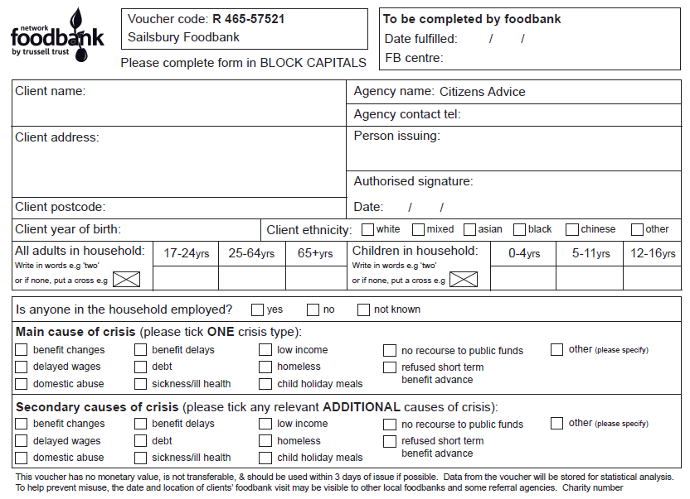



❑

❑

❐

□

■

●

❍

⬧

❒

Please fill in all parts of the voucher, other than the panel to be completed by the foodbank. Individual data helps us understand and respond to the client’s situation, while combined data enables understanding and evidencing of patterns and trends.
- Please leave this section for the foodbank to complete
- Please write the client’s forname and surname 
- Please include sufficient of the address to accompany the post code
- Best contact number for authorised signatory
- The name of the authorised signatory (person issuing the voucher) should be written here
- The same authorised signatory must also sign the voucher here
- The postcode is essential for anyone with a place of residence
- Please include the client’s actual or approximate year of birth
- This is the number of adults and children in the household to receive foodbank assistance. This information should be written in words, as opposed to numbers, which can easily be altered. Blank cells must be crossed out for the same reason.
- Main cause of crisis: please only tick one box, the most appropriate, even if the client has more than one major contributory crisis.
- Secondary causes of crisis: please tick any that apply.

Register of Authorised Signatories
- The register of authorised signatories lists all the people in your organisation who are authorised to issue red vouchers or emergency food boxes. This is an important part of the voucher authentication process, enabling us to validate vouchers when presented.
- NB: only colleagues who have attended our induction and/or have been briefed directly by Ballymena foodbank are authorised to become signatories and only registered signatories should complete the voucher.
- In the event of personnel changes, please contact the foodbank office to arrange an induction for new signatories.

Queries
- If you have any queries or wish to discuss any of the information in this handbook further, please contact Janice Colgan, the foodbank coordinator on 07766104329 or Linda Thompson, Trussell Trust Area Manager by email: Linda.Thompson@trusselltrust.org

FOODBANK CENTRE OPENING TIMES & LOCATIONS

Foodbank Centre | Day | Session Times | Location/Address
Ballymena Foodbank | Monday & Wednesday | 11:00 – 13:00 | Dream centre  Ballee Drive  Ballee  Ballymena  BT42 3EX
Ballymena North | Thursday | 10:00 – 12:00 | Ballyloughan Church  Doury Road  Ballymena  BT43 6JE

If you ever have time to pop in to one of our foodbank centre sessions to see first hand how we look after and support clients, please do feel free to drop by – we would love to see you!

Client data from referral vouchers is stored securely in an online database. This data is only used to monitor client visits, and to generate aggregate data to analyse patterns and trends at local, regional or national level. The date and location of a client’s visits may be visible to other foodbanks and some referral agencies, to monitor repeat visits. A data privacy statement for client data is available from the foodbank on request.
Your organisations’ contact data will also be stored in the foodbank data system. It will only be used to contact you regarding foodbank activity and clients. It will not be shared with any third parties. A data privacy statement for referral agency data is available from the foodbank on request.

